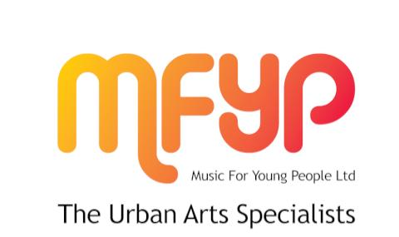

At MFYP Ltd, we want to ensure our learners have access to free, quality careers advice and guidance.
What Information, Advice and Guidance (IAG) can I expect at Music For Young People?
We aim to provide you with comprehensive support through our Information Advice and Guidance team. Your mentor will support you through your time at Music For Young People through regular input in your course and also 1:1 support where needed.
Our staff can offer you the following services:
- Impartial and unbiased advice on the courses we provide.
- Information regarding the qualifications and career paths that our programmes offer.
- Guidance and support when you are facing personal difficulties.
- Referrals to other local learning providers if our courses are not suitable for you, or we cannot meet all your needs.
- Assessment to make sure the course level is right for you.

- Access to employability support, helping you with CV writing, application forms, interview tips and your personal skills.
- Access to advice on progression into work, apprenticeships or further learning.
- On some of our courses, we will help you access work placements.

Our commitment to you
You can also expect:
- You will get free access to the Internet for job hunting.
- Your meetings with your Tutor and IAG Adviser will remain confidential[1].
- We will actively promote Equal Opportunities and Diversity.
- We will welcome the opportunity to receive your feedback on the quality of our service to you.
- We will actively strive to improve our services based on your feedback and our own Quality Improvement measures.
Further information on our IAG programmes:
Music For Young People
12 Silver Street, Bury
BL9 0EX
Tel: 0161 222 6454
Email: info@mfyp.org Web: www.mfyp.org

* This statement was last updated on 2nd September 2013
IAG support is confidential in line with our Safeguarding duties: we are legally required to share any information that could prevent a young person being harmed

MFYP Ltd
© 2014 | PRIVACY POLICY

