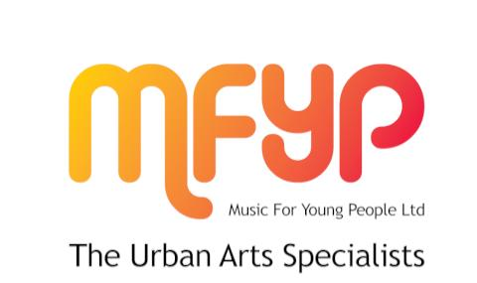
VOLUNTEER AGREEMENT

This Volunteer Agreement describes the arrangement between MFYP Ltd and you. We wish to assure you of our appreciation of your volunteering with us and will do the best we can to make your volunteer experience with us enjoyable and rewarding.
Part 1: the organisation
Your role as a volunteer is as a youth music mentor and positive role model and starts on June 2013. This volunteering role is designed to support young people to develop their creative music-making, Art, improve their skills, develop their resilience and resources to cope with challenging circumstances and to present them with a positive role model and listening friend.
You can expect MFYP Ltd to:
1. Induction and training
• To provide a thorough induction on the work of MFYP Ltd, its staff, your volunteering role and the induction and/or training you need to meet the responsibilities of this role. The Volunteer Handbook provides full details of the organisation.

Supervision, support and flexibility
• To explain the standards we expect for our services and to encourage and support you to achieve and maintain them;
• To provide a named person who will meet with you regularly to discuss your volunteering and any successes and problems;
• To do our best to help you develop your volunteering role with us.
3. Expenses
• To reimburse these expenses following the procedures in the Volunteer Handbook:
– Travel to and from home to MFYP Ltd, schools, youth services or other volunteering locations and during your work: see the Volunteer Handbook for rules on methods of travel and car mileage allowances
– Meal expenses to a maximum of £5 per meal. Expenses should be incurred through volunteering so to be eligible you should volunteer for at least 6 hours a day.
– Specialist clothing or equipment where this is required and provided by you.
Please keep all your receipts to give to us when we reimburse your expenses.

4. Health and safety
• To provide adequate training and feedback in support of our health and safety policy, a copy of which is in the Volunteer Handbook.
5. Insurance
• To provide adequate insurance cover for volunteers whilst carrying out their volunteering roles which have been approved and authorised by us
6. Equal opportunities
• To ensure that all volunteers are dealt with in accordance with our equal opportunities policy, a copy of which is set out in the Volunteer Handbook.
7. Problems
• To try to resolve fairly any problems, complaints and difficulties you may have while you volunteer with us;
• In the event of an unresolved problem, to offer an opportunity to discuss the issues in accordance with the procedures set out in the Volunteer Handbook.

Part 2: the volunteer
We expect you:
• To help MFYP Ltd fulfill its youth support and mentoring services which the volunteer will be helping with;
• To perform your volunteering role to the best of your ability;
• To follow the organisation’s procedures and standards, including health and safety and equal opportunities, in relation to its staff, volunteers and clients;
• To maintain the confidential information of the organisation and of its
clients;
• To meet the time commitments and standards which have been mutually agreed to and to give reasonable notice so other arrangements can be made when this is not possible;
• To provide referees as agreed who may be contacted, and to agree to a Disclosure & Barring Service check being carried out where necessary.
This agreement is binding in honour only, is not intended to be a legally binding contract between us and may be cancelled at any time at the discretion of either party. Neither of us intend any employment relationship to be created either now or at any time in the future.

* This guidance was last reviewed September 2013

MFYP Ltd
© 2014 | PRIVACY POLICY

